**CHAPTER 1**

**INTRODUCTION**

* 1. **GENERAL**

Inland Water bodies are an important economic and environment for Nation. Lakes were targeted for discharge of Industrial Effluents and Agricultural Runoff. As of increasing nutrient content to the lake results in Eutrophication .Remote sensing is the acquisition of information about an object or phenomenon without making physical contact with the object and thus in contrast to on site observation. Remote sensing is a subfield of geography. Satellite imagery have more application in Engineering and Geological field and these satellite images can also be used to predict water quality to a greater extent. In modern usage, the term generally refers to the use of aerial sensor technologies to detect and classify objects on Earth (both on the surface, and in the atmosphere and oceans) by means of propagated signals (E.g. electromagnetic radiation).

Eutrophication is the process in which water bodies undergo a shift in productivity levels. This can be a natural process as water bodies age over geological timescales. Rapid eutrophication onset by human activities is the process in which water bodies receive excessive nutrients that promote algal blooms decreasing dissolved oxygen availability, water quality, and ecosystem stability. Agricultural activities, urban runoff, alterations of adjacent landscapes, atmospheric deposition, and direct discharge of nutrients are common sources contributing to anthropogenic Eutrophication problems. Enhanced growth of aquatic vegetation or phytoplankton and algal blooms disrupts normal functioning of the ecosystem, causing a variety of problems such as a lack of oxygen needed for fish and shellfish to survive. The water becomes cloudy, typically coloured a shade of green, yellow, brown, or red. Eutrophication also decreases the value of rivers, lakes and aesthetic enjoyment. Eutrophication is recognized as an indicator of water pollution and the same water is found unfit for human consumption. Remote sensing is proved to be a viable in demarcation of the boundaries where higher concentration of chlorophyll a might exist.

**1.2 STUDY AREA FOR WATER QUALITY MAPPING**

|  |  |  |
| --- | --- | --- |
| **Study Area** | : | Pulicat Lake |
| **Coordinates** | : | 13º33’57”N latitude and 80º10’29”E longitude |
| **Area** | : | 250 – 450 km2.    **Fig 1.1 Study Area for Water Quality Assessment Pulicat Lake** |

**1.3 GEOGRAPHY**

The lagoon’s boundary limits range between 13.33° to 13.66° N and 80.23° to 80.25°E, with a dried part of the lagoon extending up to 14.0°N. With about 84% of the lagoon in Andhra Pradesh and 16% in Tamil Nadu. The lagoon is aligned parallel to the coast line with its western and eastern parts covered with sand ridges. Area of the lake varies with the tide; 450 square kilometers (170 sq. mi) in high tide and 250 square kilometers (97 sq. mi) in low tide. Its length is about 60 kilometers (37 mi) with width varying from 0.2 kilometers (0.12 mi) to 17.5 kilometers (10.9 mi). In the Andhra Pradesh part of the lake several threats to the lagoon have been identified. These are: pollution from sewage, pesticides, agricultural chemicals and industrial effluents – from Arani and Kalangi rivers draining into the lake that bring in fertilizers and pesticides with the runoff from the agricultural field in to the drainage basin, domestic sewage, effluents and wastes from numerous fish processing units; oil spills from the mechanized boats; release of 4,780 hectares (11,800 acres) of the sanctuary for a marine chemicals and salt manufacturing industry and shrimp farming in more than 1,000 acres (400 ha) on the eastern part of the lagoon have affected the Pulicat Bird Sanctuary; livelihood of 30,000 fishermen and 20,000 agricultural labourers (for whom fishing is an off season economic activity) have also been disturbed. Due to increase in pollutants the lake quality is degrading and the aquatic fisheries has started to degrade. Chlorophyll a count in areas where higher nutritional content is found showed a significant result in their count. Synergistic approach that combines bio optical and three dimensional modeling was useful for explaining the horizontal phytoplankton surface distribution in the IHR *(M.P. Curtarelli, 2014).*

**1.4 NEED FOR THE STUDY**

The purpose of this study is to evaluate a remote sensing method for real time monitoring of water quality. Reflectance in the range from 400 to 950 nm with a spectral resolution of 2 nm, simultaneously with turbidity, chlorophyll a and total suspended matter contents were acquired in two water systems: The reflectance spectra of water effluent were investigated in order to develop algorithms for remote estimation of water quality expressed as chlorophyll a, bacterium chlorophyll a, nonorganic and total suspended matter concentrations. Reflectance height at 720 nm and an area above the base line from 670 to 950 nm were used in algorithms for chlorophyll an assessment. An area under the base line, through 780 to 900 nm, was found to be a measure of bacteria chlorophyll-a. Reflectance around 570 nm and reflected light in the range 400 to 950 nm were used to assess total suspended matter concentration. Chlorophyll a is used as an indicative measure for Eutrophication which results. To develop a Remote Sensing method for real time monitoring of Water quality.

As the growing demand for clear water is increasing every day, easy and readily available technique is needed for assessment of Water. Turbid water is an indicator of higher dissolved solids in it, Turbidity of water bodies can be found using remote sensing. Fisheries can be found in regions where higher DO is present and if a certain place appears to have higher Chl a, the water will have reduced sunlight passage and DO will be less.

To study, develop and validate indicators of nutrient and dissolved oxygen (DO) impacts on estuarine condition, and to integrate the suite of indicator responses through models that can be used to describe the “Health” of an estuarine ecosystem

Thiruvallur Region is a growing Urban Sector that has attracted people around the Region, as of an increasing Population growth the need for study on its Eutrophication status of Pulicat Lake is compulsory.

**1.5 SCOPE OF THE WORK**

Remote sensing is considered as a viable tool in analyzing environment. The extent to which the lake has undergone pollution will be analyzed. Monitoring Chlorophyll Growth in lake will allow us to study the exploitation of water resources and contamination of Lake. Turbidity can be measured by passage of light through the water body as of higher TDS is found the water will appear blurry. Fishery migration will be predicted and the areas where water undergone oxygen depletion will be found. This will greatly improve on Aquaculture.

**1.6 OBJECTIVES OF THE STUDY**

* To study the reflectance characteristics of water.
* To study the areas where higher concentration of chlorophyll a and turbidity is found.
* To study effects of eutrophication.
* To prepare a linear regression and to model for satellite images.
* To demarcate areas where anoxic conditions will prevail.
* To improve aquaculture over the region.

**CHAPTER 2**

**LITERATURE REVIEW**

**2.1 GENERAL**

Chlorophyll a Concentration mapping is very important to monitor the harmful contaminants as by a way to delineate the cause for Eutrophication. The Aquatic Life forms will generally undergo loss in Dissolved Oxygen content as that of a result Chlorophyll absorbs the DO content and increases the concentration of CO2.

**2.2 GIS AND REMOTE SENSING**

The Landsat Satellite Imagery is an improved GIS and remote sensing method that can be used to estimate individual level agricultural pesticide exposure at geocoded locations. The Landsat Satellite Imagery addresses the dynamic nature of agriculture, especially crop rotations, through providing an approach to match pesticide applications to crop fields classified from temporally concurrent Landsat images rather than outdated LUS crop fields from the standard GIS method in California*. (Trang VoPham,* 2014*)*.

Development of a suite of now casting and forecasting methods by using high resolution remote sensing based monitoring techniques on a daily basis. First, the integrated data fusion and mining (IDFM) technique was applied to develop a near real time monitoring system for daily now casting of the TSS concentrations. With the aid of remote sensing imagery, local sensor networks, and machine learning techniques, the now casting models developed in this study are able to capture the spatial and temporal distributions of TSS concentrations throughout a lake *(Sanaz Imen, 2012)*.

**2.3 IMAGE ANALYSIS BASED UPON BAND MATCHING**

Reflectance characteristics of Oil and their corresponding Hemispherical Reflectance value. Spectroscopic characterization of oils yielded from Brazilian offshore basins: Potential applications of remote sensing. Band Wavelengths of VNIR and SWIR are found to be useful in mapping oil Disaster **(***Talita Lammoglia*, 2014). Enhanced satellite remote sensing of coastal waters using spatially improved bio optical products from SNPP–VIIRS **(***Ryan A. Vandermeulen* ,2014).

Chlorophyll mapping using regression model analysis.A semi analytical procedure for the spatial enhancement of ocean color products in optically complex waters was demonstrated for the SNPP–VIIRS sensor, providing improved products for resolving coastal dynamics. Identification of phytoplankton functional groups is key to understanding marine biogeochemical cycles. For accurate understanding of phytoplankton community structure and its implications for ocean color remote sensing applications, investigation on seasonal changes in phytoplankton pigments with high performance liquid chromatography were studied and Hyper spectral band matching options were chosen (*Tomonori Isada* *,*2014).

Accuracy assessments for band ratio or spectral inversion algorithms based only on in situ measurements Spectral inversion procedures match spectral measurements with bio-optical forward models by means of inversion techniques. The Linear equation is applied to whole image which acts upon individual reflectance values and establishes a known reflectance value based upon our study, (*Kostadinov, 2007*).

**2.4 CHLOROPHYLL AND TURBIDITY MAPPING**

Mapping Chlorophyll-*a* Concentrations in West Lake, China using Landsat 7 ETM+ Trophic status indexas a function of chlorophyll concentration. The straight forward linear regression model between chlorophyll-*a* and Landsat band ratio was useful in mapping lake water quality and trophic status *(Nathan Torbick,* 2008*).*

Chlorophyll a concentration across a trophic gradient of lakes .An estimator of phytoplankton biomass Peter Phytoplankton Concentration via weighted analysisChlorophyll a count in areas where higher nutritional content is found showed a significant result in their count (*Kasprzak*, 2008).

Synergistic approach that combines bio optical and three dimensional modeling was useful for explaining the horizontal phyto plankton surface distribution in the IHR. The method provided not only information about the horizontal phytoplankton surface distribution but also information about water column stability processes. The Information makes it possible to understand the impacts of external forces on the water column and to understand the consequences of those forces on phytoplankton dynamics. Insitu sampling of chlorophyll-a (CHL) is costly and time consuming (*M.P. Curtarelli*, 2014).

Algal peaks might be missed either spatially or temporally due to the fast changing algae growth, especially in spring .The careful determination of in situ locations and necessary sampling frequency is therefore crucial for a coherent and comprehensive overview of the chlorophyll dynamics in a lake (*Isabel Kiefer,* 2015).

Using MERIS satellite images, the present article showed a convincing method to analyze the representativeness of an insitu sampling location*.* Mapping of phytoplankton phenology features using satellite imagery in a freshwater setting has been presented in this work, and is foreseen to be an important continued direction in the remote sensing of inland waters (*S.C.J. Palmer,* 2015*)*.

The land cover and the economic activity in the watershed seems unchanged over the last ten years the factors affecting the optical characteristics of the water are far complicated than Predicted (*Essayas K. Ayana* ,2015).

TSI calculations points to the poor applicability of TSI to water quality data from Pulicat Lagoon. Successful construction and application of an index depicting the trophic status would require a rigorous understanding of the complex inter-relationships between the physical, chemical and biological factors that influence the trophic status of a coastal lagoon (*Harini Santhanam,* 2009).

Reports from relatively large, deep lakes that have been subjected to nutrient reduction (surface area >45 km2 and mean depth >30 m) have indicated that a decline in phytoplankton biomass and or production, as well as an increase in water transparency, typically occurs within 6–10 years after initiating nutrient controls (*Edmondson and Lehman,* 1981) There were seasonal differences in the deposition of phosphorus to and release from the sediments, the average net long term retention being about 57% of the income; slight changes in retention during and after diversion resulted in a greater fraction of the influent being lost to the sediments after diversion. The amount of phosphorus lost permanently to the sediments during a year is more closely related to the annual income than to the mean concentration in the water. However, there is a considerable variability in the time lag of the response (*Dokulil,* 1993*,*), and some of these lakes have shown a decline in phytoplankton biomass only in summer (*Lake Constance, Häse,* 1998).

Moreover, a recent cross system study has revealed that a substantial number of large deep lakes did not follow the general pattern found for smaller lakes (*Jeppesen ,* 2005) conclude that phytoplankton, and probably also fish, responded rapidly to reduced loading, whereas the effect on zooplankton was less pronounced. However, increases in body weight of cladocerans and the zooplankton to phytoplankton biomass ratio during summer indicate reduced top-down control on zooplankton and enhanced grazing on phytoplankton. The conclusion is supported by a tendency for fish biomass to decline and a shift towards greater dominance by piscivores and, thus, an increased likelihood of predator control of zooplanktivorous cyprinids, highlighting the complexity of the re-oligotrophication process. Recovery from eutrophication is complex and depends on many factors, including internal nutrient regeneration, water temperature and lake morphometric (*Genkai-Kato and Carpenter*, 2005), as well as food web structure .Investigating individual lakes can help improve our understanding of the mechanism of oligotrophication, given that individual lakes may exhibit a specific trajectory as a result of their unique characteristics (*Smith and Shapiro,* 1981).

Radiative transfer considerations combined with the field turbid waters data showed that different optical models for remotely sensed chlorophyll concentration. A new analytical approach for retrieval of the vertically weighted chlorophyll *a* concentration (⟨Chl⟩rs) detected by remote sensors is presented. Model calculations were carried out for the turbid waters of Lake Kinneret, Israel, and showed that ⟨Chl⟩rs may be replaced by the average chlorophyll *a* concentration (⟨Chl⟩p) within the upper “penetration layer”. This study also showed a high correlation between ⟨Chl⟩rs and Chl concentration averaged in the other depth layers, namely, the 0–1 m layer, the euphotic layer (0–𝑍e), and the production layer (0–𝑍pr). We showed the effect of the pattern of vertical Chl distributions within the penetration layer on the difference between ⟨Chl⟩ rs and other Chl indices was conspicuous when the Chl maximum was in the uppermost 0–5 m layer of the water column. It assumed that the presented approaches are instrumental for further development of optimal, locally adapted algorithms for remote sensing of Chl in any type of natural waters. (*Leonid G. Sokoletsky and Yosef Z. Yacobi*, 2011).

The variables studied were investigated using Kendall's Tau statistics and least-square regressions (*Legendre and Legendre*, 1998), Multiple regression and Linear regression were used for simplication as to obtain the ground values , variables were then plotted against independent variables over time to check for evidence of serial dependence (*Carpenter,* 1992).

Parameters of a phosphorus cycling model were estimated for two configurations of a lake ecosystem. The piscivore-dominated configuration had one more trophic level than the planktivore-dominated configuration. We derived four main conclusions from analysis of the model. Results support the argument. The Turnover rate of a limiting nutrient is directly related to ecosystem resilience. Results support the hypothesis of Pimm and Lawton that longer food chains are less resilient. Inputs of phosphorus to the pelagic system derived from inshore feeding by fishes were a large flux, which is comparable to inputs from physical-chemical fluxes. Algal standing crops, unlike all other compartments, were less sensitive to phosphorus inputs in the piscivore-dominated system. Consistent with the trophic cascade hypothesis, the piscivore-dominated system had higher herbivore standing crops and lower algal standing crops than the planktivore-dominated system. Changes in trophic structure that derive from trophic cascades can be viewed as changes in the phosphorus cycle driven by fishes (*De Angelis et al,* 1998).

**CHAPTER 3**

**MATERIALS AND METHODS**

**3.1 GENERAL**

In this study chlorophyll-a and turbidity concentration parameter are analyzed. The materials and methodology adopted for this study is discussed in this chapter. The project work has been divided into four parts

1. Collection of Satellite Images.
2. Software modules for analysis of Satellite Images.
3. Collection of sample.
4. Analysis of sample.

**3.2 IMAGE ANALYSIS AND SOFTWARE MODULES**

Satellite images of Landsat 7 and ETM+ were obtained from USGS (NASA observatory) for the year 2015 and 2016. The Images were selected on a cloud cover of less than 10% , for non erroraneous approach. These Image are selected on a basis of less than 20% cloud cover as of clearer approach for study Area. The Images are subjected to Atmospheric and Radiometric Correction to calibrate their reflectance values. The Study area (Pulicat Lake) is extracted by a Shape polygon file using ENVI Software (ENVI 5.1.1) .This Software is later used to analyses the Image.

**3.3 MATERIALS REQUIRED**

**3.3.1 Chlorophyll-a Analysis**

* GPS
* Satellite Image
* 2000ml Bottles
* Magnesium Carbonate

**3.3.2 Turbidity Analysis**

* SDT
* Measuring Tape

**3.3.3 Laboratory Instruments**

* Burette
* Pipette
* Beaker
* Measuring Flask
* Spectrophotometer
* Centrifuge

**3.4 COLLECTION OF PREVIOUS DATAS**

USGS provides data for past 15 years of Landsat 7 ETM+ .The Datas were selected as of low cloud cover which is basis for analysis of Chlorophyll-a Concentration. The Images collected has to undergo Radiometric, Geometric and Atmospheric correction to tender exact reflectance values

**3.5 SAMPLE COLLECTION**

Lake samples will be collected in a random manner with the help of Secchi Disk Technique. The samples collected will be subjected to test within 6 hours. The Samples collected will be added with few milligrams of MgCO3 which is added for preservative of the Phytoplankton. The Samples can be stored under Laboratory Freezer for 2 weeks under a temperature of 00 C to -20 C. Secchi Disk is dropped into the water body and the distance at which it completely disappears is noted.

**3.6 ANALYSIS OF PHYSICAL CHEMICAL PARAMETER**

Water sample collected will be analyzed under laboratory conditions for their parameters like salinity conductivity, TDS, by appropriate Instruments. Chlorophyll-a estimation will be done using Spectrophotometer available in laboratory.

**3.6.1 Color**

In natural water, color is due to the presence of humic acids, fulvic acids, metallic ions, suspended matter, plankton, weeds and industrial effluents. Colour is removed to make water suitable for general and industrial applications and is determined by visual comparisonof the sample with distilled water.

***Visual comparison:*** About 20ml of the sample and 20ml of distilled water were taken in two separate wide mouthed test tubes. The results were tabulated (as clear, greenish, greyish, brownish, blackish, etc.) by comparing the color of the sample with distilled water.

**3.6.2** **Turbidity**

Turbidity is an expression of optical property; where in light is scattered by suspended particles present in water (Tyndall effect) and is measured using a nephelometer. Suspended and colloidal matter such as clay, silt, finely divided organic and inorganic matter; plankton and other microscopic organisms cause turbidity in water. Turbidity affects light scattering, absorption properties and aesthetic appearance in a water body. Increase in the intensity of scattered light results in higher values of turbidity.

***Apparatus required***

The Turbidity of a body of water is related to the cleanliness of the water. Waters with low concentrations of total suspended solids (TSS) are clearer and less turbid than those with high TSS concentrations. Turbidity can be measured using several methods. The easiest and least expensive method is through the employment of a Secchi disk. Turbidity then can distributed among spatially using linear regression line fit.



**Fig 3.1 Secchi Disk**

**3.6.3 Dissolved Oxygen**

Dissolved oxygen refers to the level of free, non-compound oxygen present in water or other liquids. It is an important parameter in assessing water quality because of its influence on the organisms living within a body of water. In limnology (the study of lakes), dissolved oxygen is an essential factor second only to water itself.  A dissolved oxygen level that is too high or too low can harm aquatic life and affect water quality. The amount of dissolved oxygen needed varies from creature to creature. Bottom feeders, crabs, oysters and worms need minimal amounts of oxygen (1-6 mg/L), while shallow water fish need higher levels (4-15 mg/L).

***Method***

Titration Methods is used to analyze DO, 10 ml of N/80 KMnO4 was taken and 10 ml 25% H2SO4 in a 500 ml was added in the wide mouth bottle. Kept in the dark. After 4 hours, 2 ml of 10% KI solution was added. Iodine was titrated with N/80 Thiosulphate using starch as indicator. End point observed was disappearance of blue color. Titrated volume was noted (T1). 250 ml or a portion of the sample was taken in a wide mouth 500 ml bottle (V1). 10 ml 25% H2SO4 + 10 ml N/80 KMnO4 was added Allowed to stand for 4 hours in the dark. If the pink color fades or disappears in the middle, add additional 10 ml portion of N/80 KMnO4. Total volume of N/80 KMnO4added is noted (V). After 4 hours, add 2 ml 10% KI solution. Iodine liberated was titrated with N/80 Thiosulphate using starch as indicator. End point is disappearance of blue color. Titer volume is noted (T2).

**Tidy’s value mg/l = (T1x V/10)-T2 x (8/80) x (10/T1) x (1000/V1)**

**= (T1x V/10)-T2] x [(1000/ (T1 x V1)**

**3.6.4 TOTAL DISSOLVED SOLIDS**

Dissolved solids are solids that are in dissolved state in solution. Waters with high dissolved solids generally are of inferior palatability and may induce an unfavorable physiological reaction in the transient consumer.

***Apparatus Required***

Take 20 ml of Water sample in a beaker and filter through what man filter paper and it is washed several times with Distilled water. Then the precipitate is taken in a pre-weighted crucible and ignited in muffle furnace .The Precipitate is cooled in the Desiccator and the difference in weight is found.

**3.6.5** **Nitrates NO32-**

Excessive accumulation of oxidized nitrogen in the form of nitrates may result in high concentrations of nitrates in the Water bodies, which in some cases may exceed the 50 mg/l limit for water consumption. Due to the cumulative character of nitrates in Water bodies, concentrations higher than 25 mg/l should be treated with concern, calling for preventive actions. In surface waters, particularly lakes and closed gulfs, excessive accumulation of nitrogen as well as phosphorus may lead to eutrophication, with adverse impact, due the proliferation of algae and their byproducts, on fish, oxygen levels and amenity value.

***Method:*** UV Visible Method.

**3.6.6 Phosphate PO43-**

PhosphatesPO43- are formed from this element. Phosphates exist in three forms: orthophosphate, metaphosphate (or polyphosphate) and organically bound phosphate each compound contains phosphorous in a different chemical arrangement.  These forms of phosphate occur in living and decaying plant and animal remains, as free ions or weakly chemically bounded in aqueous systems, chemically bonded to sediments and soils, or as mineralized compounds in soil, rocks, and sediments. These Phosphates when enter into water bodies they increase the nutrient content of water .Thus making a richer affinity for growth of Phytoplankton (algae). Significant increases in algae harm water quality, food resources and habitats, and decrease the oxygen that fish and other aquatic life need to survive.

***Method***

Take 50 ml or a portion of sample diluted to 50 ml (V). Then 1 ml Conc. H2SO4 and 5 ml Conc. HNO3. The solution was Digested to 1 ml and continued to heating until the solution became colorless so that HNO3 is completely removed. Solution was Cooled and addded to 10 ml doubled H2O. Then the solution was Neutralised with 6 N NaOH  (to pale pink end point with phenolphthalein ) filter and made up to 50 ml. Then 2 ml molybdate reagent and 5 drops of stannous chloride were added. After 10 minute but before 12 minutes O.D was measured at 690 nm (S).

**Control Standard**: 10 ml of CONTROL Std and diluted to 50 ml with doubled. H2O. Then 1 ml Conc. H2SO4 and 5 ml Conc. HNO3 were added. The solution was digested to 1 ml and continued to heating until the solution became colorless so that HNO3 was completely removed. Then the solution was Cooled and added 10 ml doubled. H20, neutralised with 6 N NaOH  (to pale pink end point with phenolphthalein ) filter and made up to 50 ml. Then added 2 ml molybdate reagent and 5 drops of stannous chloride and after 10 minutes but before 12 minutes O.D measured at 690 nm (S).

**Blank**: 50 ml doubled. H20. Add 1 ml Conc. H2SO4 and 5 ml Conc. HNO3 were digested to 1 ml and continued to heating until the solution became Colorless so that HNO3 was completely removed and Cooled then added 10 ml doubled. H2O. to neutralise with 6N NaOH (to pale pink end point with phenolphthalein) filter and made up to 50 ml. Then added 2 ml molybdate reagent and 5 drops of stannous chloride. Blank was kept for zero setting of the meter

**CALCULATION:**

Phosphate as PO43- mg/L = [S x Ps x (50/V)] (V :Volume , S:Solution , Ps :Slope)

**3.6.7 Chlorophyll – a**

Chlorophyll *a* is a specific form of chlorophyll used in oxygenic photosynthesis. Chlorophyll is a color pigment found in plants, algae and phytoplankton. This molecule is used in photosynthesis, as a photoreceptor. It is found in Phytoplankton which is a living microorganism that exist as algae and cyanobacteria. Phytoplankton, both algae and cyanobacteria, can be found in fresh or saltwater. As they need light to photosynthesize, phytoplankton in any environment will float near the top of the water, where sunlight reaches. The Phytoplankton found in water absorb Dissolved Oxygen (DO) and produce Carbon di Oxide (CO2) in water, thus making it acidic to aquatic life forms.

***Method***

Up to 1 L of sample is filtered onto Whatman Filter Paper of pore size 47mm filter, 1 ml of magnesium carbonate solution (1 g per 100 ml ddH2O) is added during final few hundred ml of filtering, desiccate the filter well under suction (*Strickland and pearson, 1972*). The filter is placed in a 15 ml centrifuge tube and placed on ice until analysis. 12 ml of 90% acetone/ 10% water added, the tube is sealed and shaken vigorously. The tubes are placed in a refrigerator (in the dark) for about 20 hours, shaking them once more at 1 or 2 hours. Shake once more and spin the filters down for 15 minutes @ 5000 rpm. Decant the supernatant into a 10 cm path length cell, or 1 cm cuvette Immediately read and record absorbance @ 750 nm and @ 664 nm, then acidify with 100 m. l (10 cm cell) or 20 m. l (1 cm cell) of 1.2M HCl, mix well and read again @ 750 nm and 664 nm.

**3.7 METHODOLOGY**

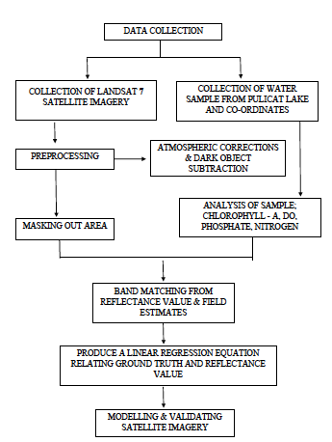

**Fig 3.2 Methodology for Chlorophyll –a and SDT Estimation**

**3.8 CHLOROPHYLL ESTIMATION FOR PULICAT LAKE**

Eutrophication is the process in which water bodies undergo a shift in productivity levels. This can be a natural process as water bodies age over geological timescales. Rapid eutrophication onset by human activities is the process in which water bodies receive excessive nutrients that promote algal blooms decreasing dissolved oxygen availability, water quality, and ecosystem stability. Satellite data were collected as of a prior step to chlorophyll estimation and a chlorophyll estimation algorithm was run in band math.

The Sample water is collected and tested in Spectrophotometer for the concentration of chlorophyll a in it which then studied under Landsat images for suitable reflectance bands. Band Matching Technique principle is used from ENVI Software which in turn gives a model Equation of Band Matching Technique principle is used from ENVI Software which in turn gives a model Equation of Y=mX +C.

This Equation is matched upon RMSE analysis which throws out the window for rough chlorophyll Estimation. The straightforward linear regression model between chlorophyll-*a* and a Landsat band ratio was useful in mapping lake water quality.

**3.8.1 Data**

USGS provides satellite imagery on a periodic basis for analysis .The Landsat7 ETM+ scene was obtained from the USGS (NASA) Data Archive System for analysis. Landsat orbits in a sun synchronized pattern at an altitude of 705 km with a repeat interval once every 16 days. Eight spectral bands are collected in the visible, near infrared, short wave infrared, and thermal portions of the spectrum at 15, 30 (visible and near infrared), and 60 m (thermal) spatial resolutions. Data were obtained with the Scan Line Collector (SLC) in the off mode due to instrument problems which resulted in stripping (no data) across the imagery. Only a small percentage of the lake was impacted by stripping; therefore, we averaged those pixels using Landsat gap fill, the USGS produced gap filled products using two methods: Phase One, which used a full Landsat 7 image (pre 2003) to fill the gaps of the SLC off scene, and Phase Two, which incorporated more than two SLC off scenes together to create a final product. Collected images underwent Radiometric and Atmospheric Correction which includes transformation of radiance to reflectance and Dark object pixel subtraction. Correction were done to remove aerosols and sun radiation. Dark object subtraction searches each band for the darkest pixel value. Assuming that dark objects reflect no light, any value greater than zero must result from atmospheric scattering. The scattering is removed by subtracting this value from every pixel in the band. This simple technique is effective for haze correction in multispectral data.

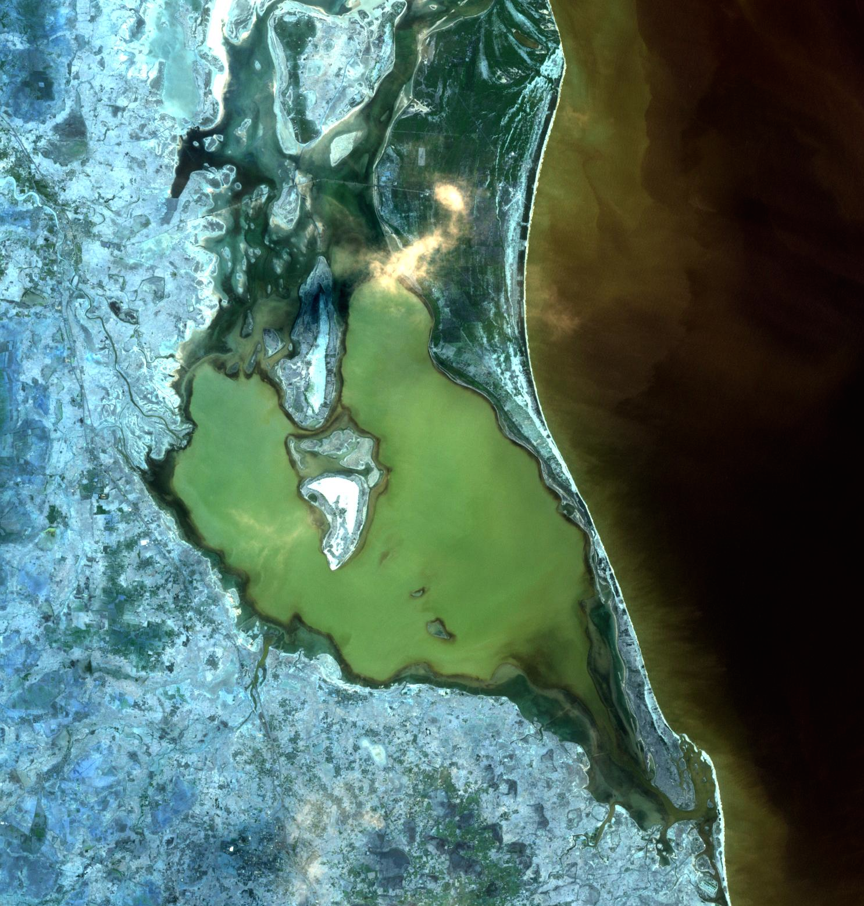

**Fig 3.3 Satellite Imagery of Pulicat Lake on August 11th 2015**

## 3.8.2 Field Measurements

Water Samples were collected for January 2016 and Turbidity was measured as SDT (m). 11 Points were taken randomly and the coordinates of these points were collected using GPS. The samples were filtered through 0.45 μm pore size filters under vacuum pressure. Pigment extraction was made by manual grinding of filter papers for 1 min and soaking in acetone 90% for 10–12 h at 4.0 °C in the dark. The extracts were clarified by centrifugation (3000 rpm, 15 min) and the concentration of Chl a was determined by spectrophotometry using the equations:

**Chl a mg/m3=11.85(Abs 664) - 1.54 (Abs 647) - 0.08 (Abs 630).**

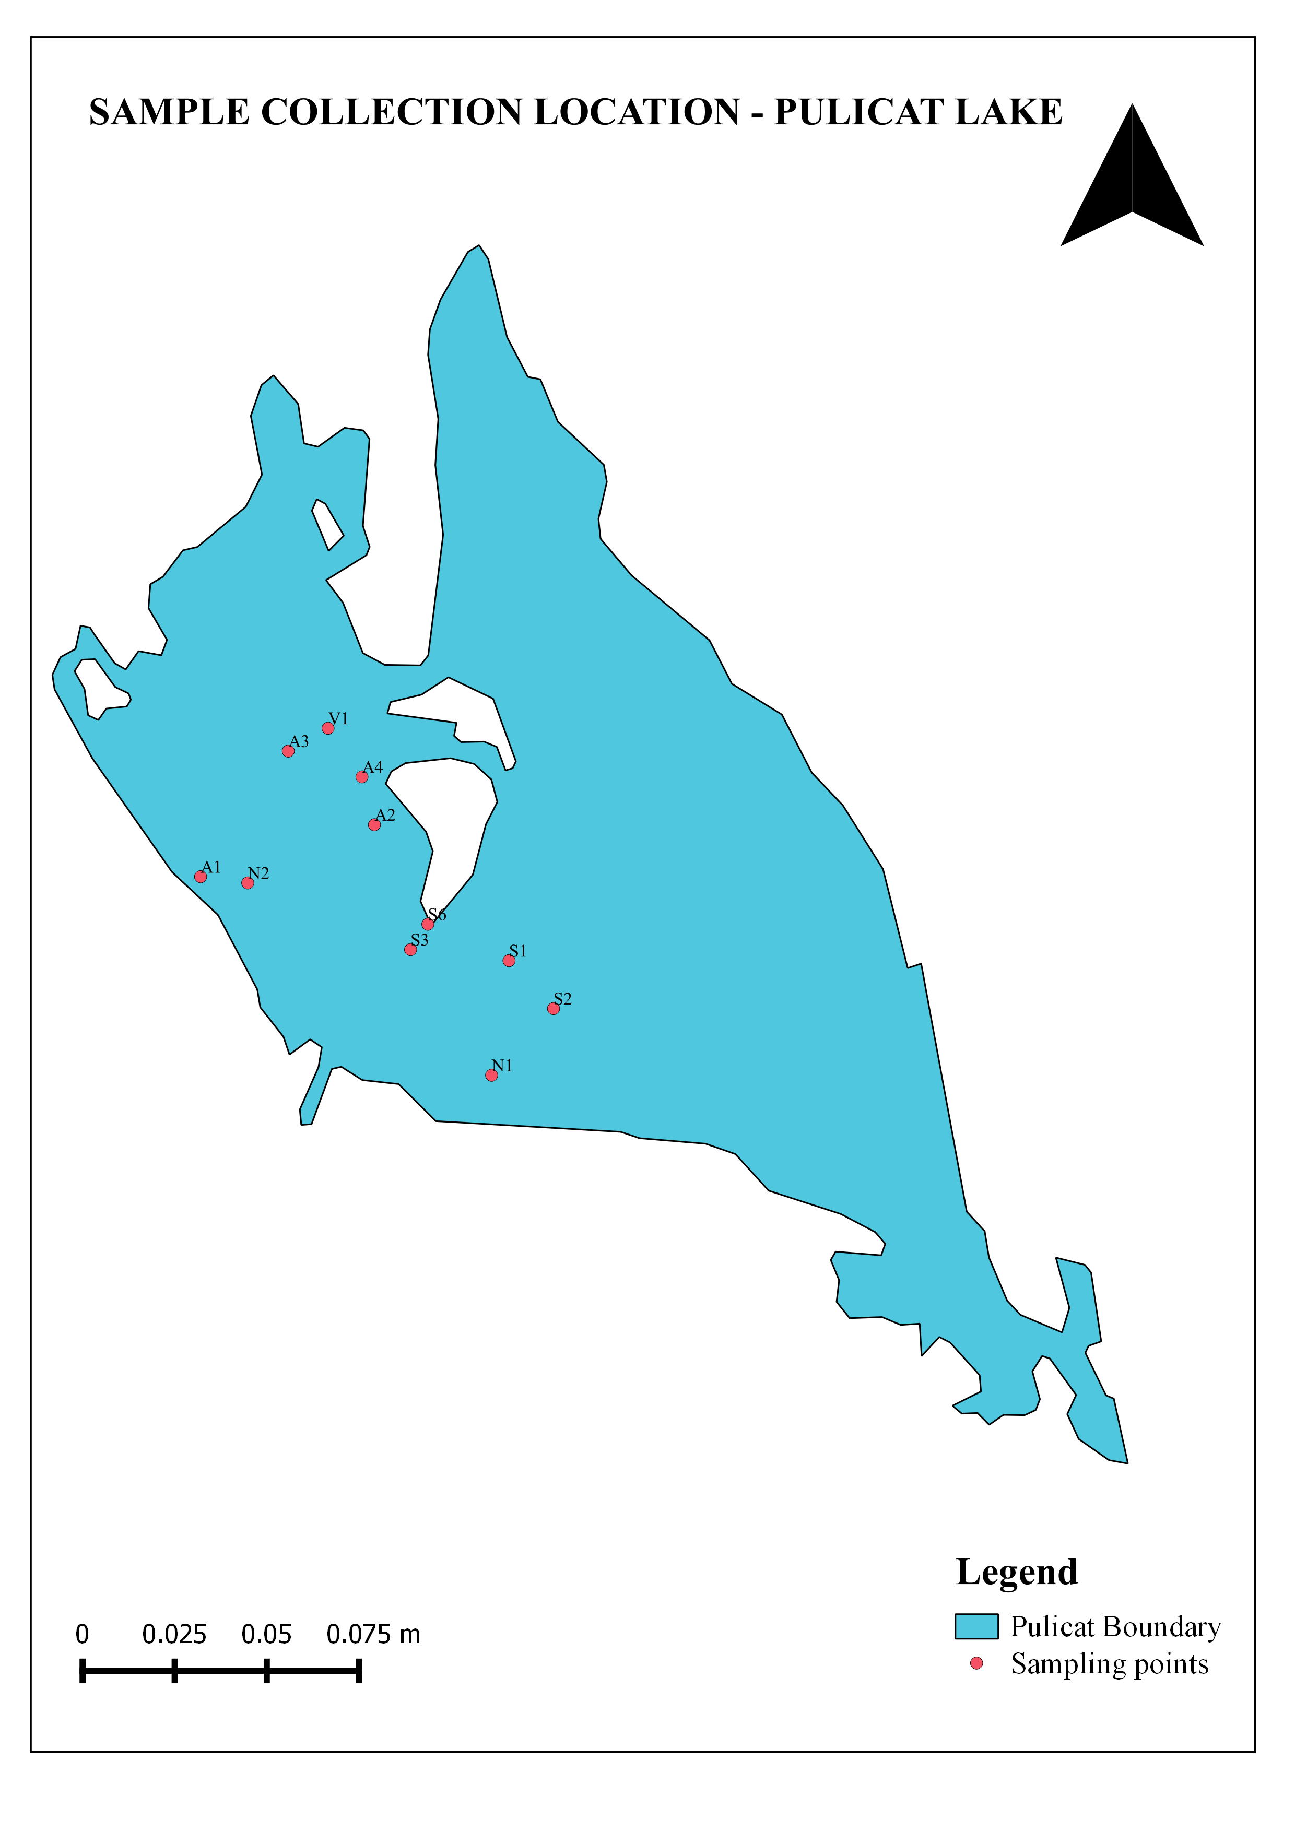

**Fig 3.4 Sample Collection Points**

**Table 3.1 Water Quality Parameters as on Jan 10, 2016**



**Table 3.2 Data Obtained on May 2016**

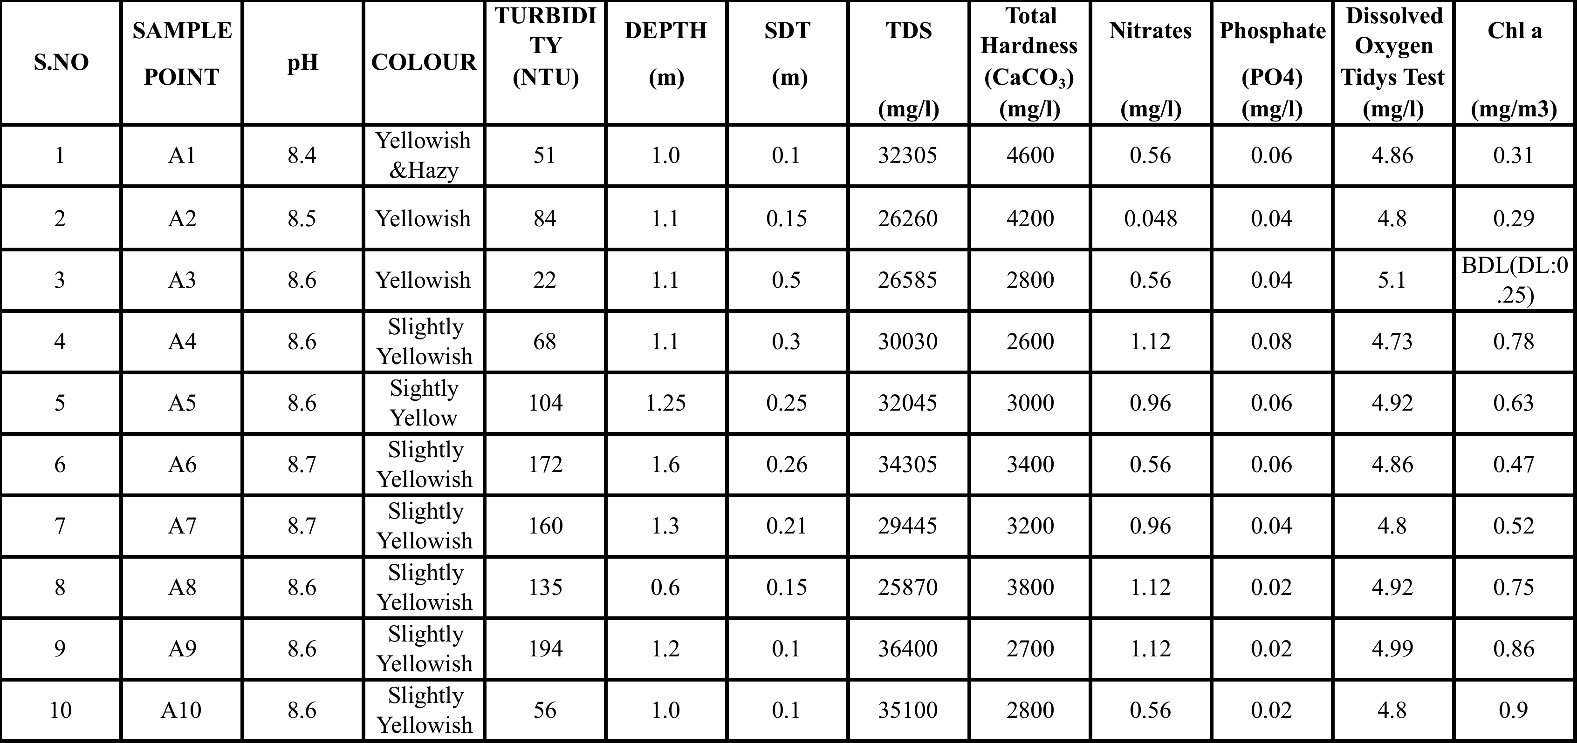

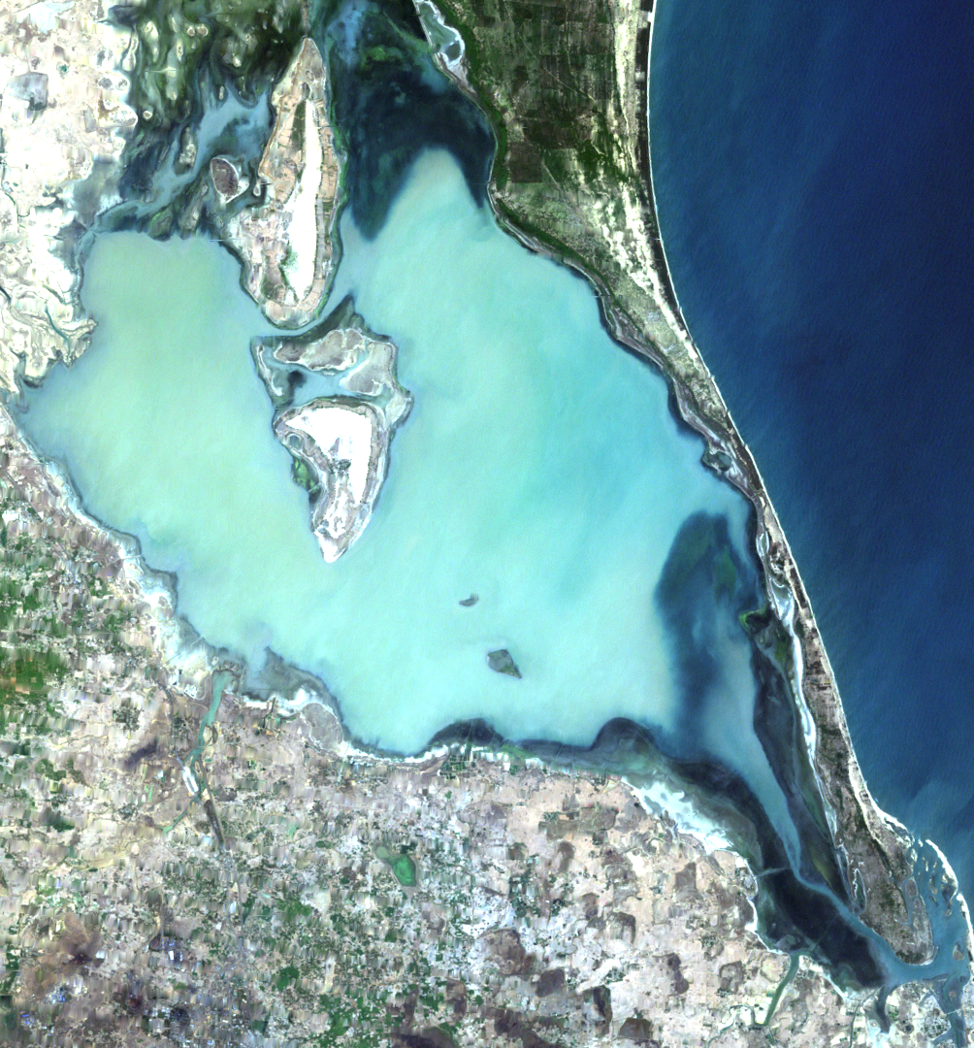

**Fig 3.5 Satellite Imagery of Pulicat Lake on May 2nd 2016**

**3.8.3 Analysis**

Numerous studies have investigated single bands, band combinations, and band ratios to estimate chlorophyll *a* concentrations in freshwater bodies. Simple linear regression was used in this study to develop a relationship between remotely sensed reflectance data and chlorophyll *a* samples. Based on the remaining samples for the dates corresponds to the Landsat data, the linear, polynomial, cubic, power and exponential models of Chl a were tested against single band as well as their band ratios.Then determination coefficients (R2) and estimated standard errors (SE) of the regression models were compared to select the best fitting data, considering different bands or their ratios. Best fit models were chosen and those linear equation is applied to other images.

**Fig 3.6 Linear Equation for Chlorophyll a**

For chlorophyll the best band ratio was chosen to be Band1/Band2 which results in higher R2 when compared to others (after Dark Object Subtraction).

**Y (chl-a mg/m3) = 8.499(B1/B2) - 5.581 (R2 = 0.73)**

Band Ratio of Blue and Green resulted in higher value which results in delineation of chlorophyll over the region.

For Turbidity mapping the SDT (m) is fitted along with reflectance of Band1/Band4 this resulted in higher R2 when compared to other band ratios (after Dark Object Subtracion).

**Fig 3.7 Linear Equation for Turbidity**

**Y (m) = 0. 3063 (B1 / B4) – 0. 8412 (R2 = 0.73)**

Band Ratio of 1 and 4 results in higher R2 and this linear algorithm is applied to Satellite Images (Dark Object Subtraction).

**3.8.4 Validation**

Chlorophyll a Analysis of submitting Month of January values to May resulted in a Validation of RMSE 0.75 and Turbidity showed a result of RMSE 0.72 for the same region.

**Fig 3.8 Validation of Chlorophyll a Data**

**Fig 3.9 Validation of Turbidity**

Chlorophyll a and SDT were obtained for Jan 2016 and these were used as reference for 2 May 2016 for validation. The 2 datas were analyzed for their consistency using satellite images of Landsat 7 and result of RMSE for Chlorophyll a was obtained to be 0.75, RMSE value for turbidity was found to be 0.72.

**CHAPTER 4**

**RESULTS AND DISCUSSION**

**4.1 GENERAL**

Stepwise these Linear Equation were applied to Image of Previous Data to demarcate the areas where higher concentration of Chlorophyll is found. The Chlorophyll Content was found to be higher during Summer Seasons which results in higher hypoxia over these regions and these area will prevail lack in Dissolved Oxygen. Correlation between band reflectance and chl a for their analysis was prepared. The Best Fit correlation is prepared and the equation was used to other images to analyze. Equation Derived was applied to Image 9 Jan 2016.

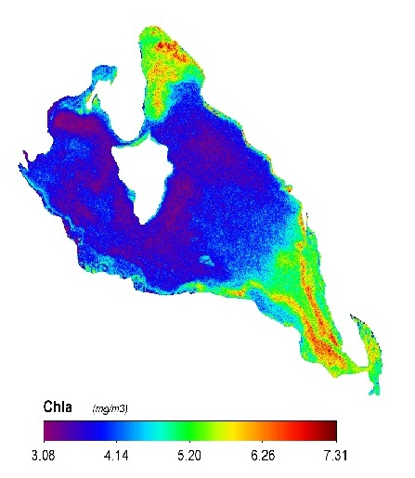

**Fig 4.1 Chlorophyll Pattern for Jan 2016**

Chlorophyll pattern for jan 2016 is found to be 3.08 <chl a<7.31 mg/m3.

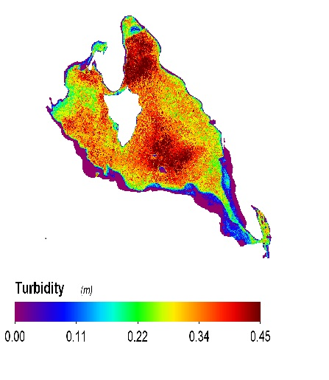

**Fig 4.2 Turbidity Pattern for Jan 2016**

To develop predictive Chl a and SDT algorithms, we constructed different regression models and LMM relating insitu data and reflectance values of the selected bands and band ratio. The Equation with higher R2 was chosen and that linear equation algorithm was applied to the images.

Satellite Images Prove to be a viable resource for estimation of chlorophyll as these directly implicate on reflectance due to their green spectrum reflectance. Amount of sunlight received during summer is higher when compared to other season. Hence algal blooms occur during summer. Moreover, algal peaks might be missed either spatially or temporally due to the fast changing algae growth, especially in spring.

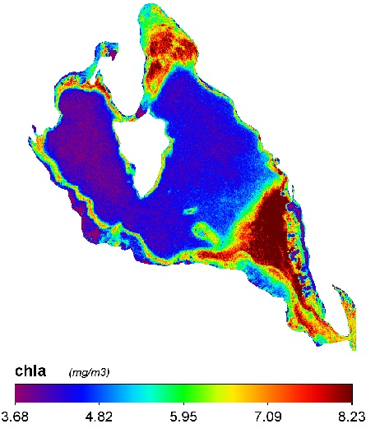

**Fig 4.3 Chlorophyll Mapping using algorithm for March 2015**

This pattern showed an increase in concentrations of chlorophyll over summer regions as the max value obtained 8.23 mg/m3.This is due to amount of sunlight received during summer season is higher when compared to other seasons.

During springs and summers river runoff increases due to rainfall. The water level decreases in summer and the runoff is also decreased. Thus the turbidity is decreased during summer season resulting in higher SDT.

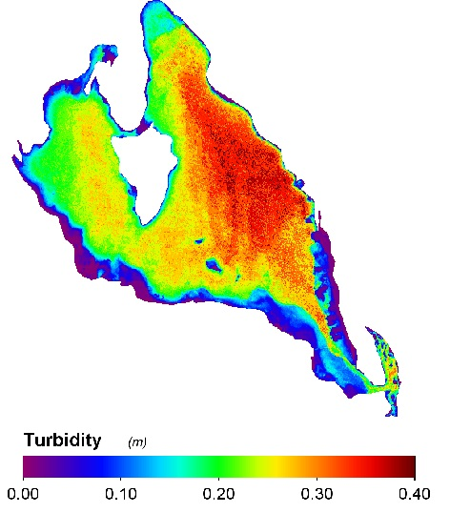

**Fig 4.4 Turbidity Mapping using algorithm for March 2015**

Chlorophyll and Turbidity pattern for May 2016, Apr 2015, and Oct 2015 are shown in Images below. May 2016 shows a range of chlorophyll 0.23<chl a<2.7 (mg/m3) and turbidity 0<SDT<0.4 (m). Apr 2015, Chlorophyll values are 0.31<chl a<2.77 (mg/m3) and Turbidity 0<SDT<0.4 (m). Oct 2015, Chlorophyll a 0.32<chl a <4.38 (mg/m3 ) and Turbidity 0<SDT<0.4 (m) . The chlorophyll values have drastically decreased from 2015 March to May 2016 .This led to decrease in phytoplankton concentration over these regions and the Dissolved oxygen content has also drastically decreased in these areas.

The temporal change for distribution of chlorophyll a and turbidity can be analysed using this linear regression model to some extent of accuracy.

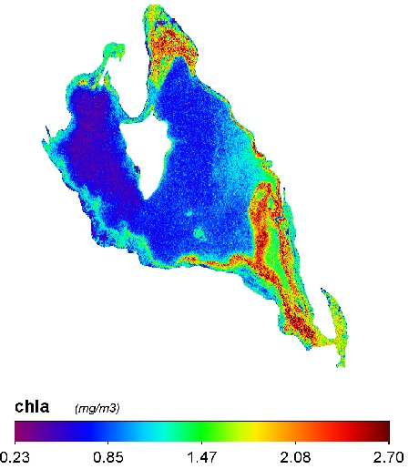

**Fig 4.5. Chlorophyll Mapping using Algorithm for May 2016**

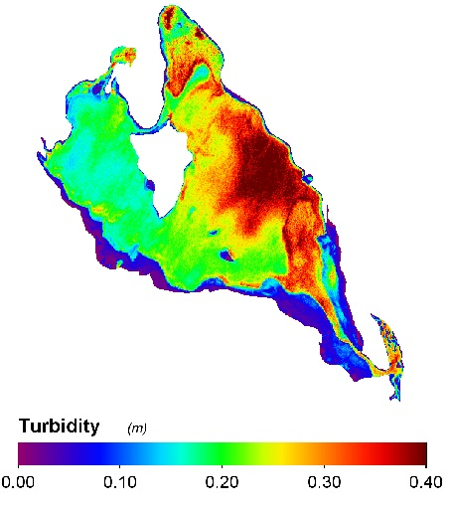

**Fig 4.6 Turbidity Mapping using Algorithm for May 2016**

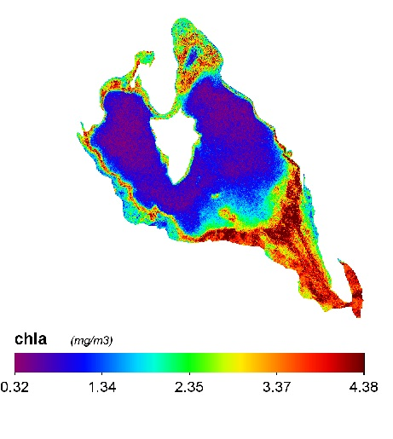

**Fig 4.7 Chlorophyll Mapping using Algorithm for Oct 2015**

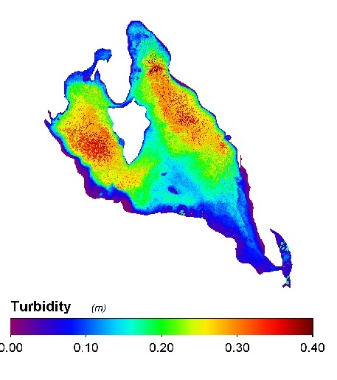

**Fig 4.8 Turbidity Mapping using Algorithm for Oct 2015**

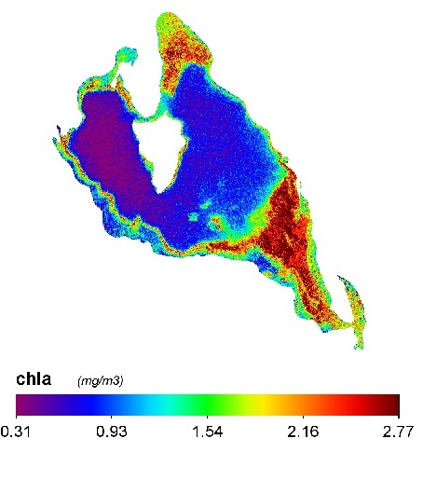

**Fig 4.9 Chlorophyll Mapping using algorithm for Apr 2015**

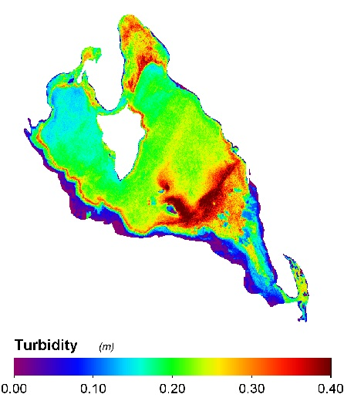

**Fig 4.10 Turbidity Mapping using algorithm for Apr 2015**

**CHAPTER 5**

**SUMMARY AND CONCLUSION**

The straightforward linear regression model between chlorophyll *a,* SDTand a Landsat band ratio was useful in mapping lake water quality. A clear zone of high productivity was present in the study area and the imagery depicted the extent of these higher concentrations. Considering this study took place during the cold to hot seasonal transition, the degree of algal growth is expected to worsen given the shallow nature of this basin. Overall, the approach was useful for assessing the status of lake and estimating the spatial patterns of chlorophyll-*a* concentrations. The Chlorophyll and Turbidity can be applied to other studies where higher concentration of Pollutants might be present.

Fishing Zones can be provided by Chlorophyll analysis as more fishes tend to live in Higher Dissolved oxygen regions. Aquaculture can be vastly improved by Real time mapping of fishing Zones. Birds all over the region have migrated to other locations as of fisheries is drastically decreased over these region. Greater Turbid Areas will infer higher Dissolved Solids in them, Water here will appear more turbid as sunlight passage is highly prevented in water.

Satellite Images and validation of results will provide a vast improvement in water Quality Assessment. After Chennai Rain during Nov and Dec 2015.The water pavement between Sea and Lake was increased as to release more runoff to Ocean. This let to the condition where more Sea water has entered into Lake as of a result the chlorophyll a over these regions has decreased and Dissolved Solids over these region has vastly increased. The lake has undergone a serious change after Flood due to these regions aquatic organisms are finding it hard to survive over these regions.

**REFERENCES**

1. Sanaz Imen., Ni-Bin Chang and Jeffrey Yang Y., 2015, “Developing the remote sensing based early warning system for monitoring TSS concentrations in Lake Mead”, *Journal of Environmental Management*, VOL.160.
2. Trang VoPham., John Wilson P., and Darren Ruddell., 2015, “Linking pesticides and human health: A geographic information system (GIS) and Landsat remote sensing method to estimate agricultural pesticide exposure”, *Applied Geography,* VOL.62.
3. Talita Lammoglia and Carlos Roberto de Souza Filho, 2011, “Spectroscopic characterization of oils yielded from Brazilian offshore basins: Potential applications of remote sensing”, *Remote Sensing of Environment,* VOL.115*.*
4. Ryan A. Vandermeulen , Robert Arnone , Sherwin Ladner , Paul Martinolich, 2015.,” Enhanced satellite remote sensing of coastal waters using spatially improved bio-optical products from SNPP–VIIRS”, *Remote Sensing of Environment*, VOL.165.
5. Salwa Farouk Elbeih., 2014, “An overview of integrated remote sensing and GIS for groundwater mapping in Egypt”, *Ain Shams Engineering Journal*.
6. Fethi Lachaal., AmmarMlayah and MouradBe dir., 2012, “Implementation of a 3-D groundwater flow model in a semi-arid region using MODFLOW and GIS tools: The Ze´ramdine–Beni Hassen Miocene aquifer system (east-central Tunisia)”, *Computers & Geosciences,* VOL.48*.*
7. Lathashri U A., and Mahesha A., 2015, “Simulation of Saltwater Intrusion in a Coastal Aquifer in Karnataka, India”, *Science Direct,* VOL.4*.*
8. Nathan Torbick and Feng Hu., 2008,”Mapping Chlorophyll-*a* Concentrations in West Lake, China using Landsat 7 ETM+”, Internet. Assoc. Great Lakes Res, VOL.34.
9. Peter Kasprzak., Judit Padisa and Rainer Koschel, 2008, “Chlorophyll a concentration across a trophic gradient of lakes: An estimator of phytoplankton biomass” *Science Direct*, VOL.327.
10. Konstantinos A. Liolios, Konstantinos Moutsopoulos N and, Vassilios A. Tsihrintzis, 2012, “Modelling of flow and BOD fate in horizontal subsurface flow constructed wetlands”, *Chemical Engineering Journal.*
11. Sindhu G., Ashitha M., Jairaj and Rajesh Raghunath, 2012, “Modelling of Coastal Aquifers of Trivandrum”, science direct, VOL.38.
12. Tomaszkiewicz M., Abou Najm and El-Fadel, 2014 “Development of a groundwater quality index for seawater intrusion in coastal aquifers”, *Environmental Modelling & Software*, VOL.57.
13. M.P. Curtarelli., I.Ogashawara , E.H. Alcântara ,J.L. Stech, 2014 “Coupling remote sensing bio-optical and three-dimensional hydrodynamic modeling to study the phytoplankton dynamics in a tropical hydroelectric reservoir” *Science Direct*, VOL.43.
14. Tomonori Isada , Toru Hirawake , Tsukuru Kobayashi , 2014 “Hyper spectral optical discrimination of phytoplankton community structure in Funka Bay and its implications for ocean color remote sensing of diatoms”, *Remote Sensing and Environment* , VOL.51.
15. Isabel Kiefer , Daniel Odermatt , 2015 “Application of remote sensing for the optimization of in-situ sampling for monitoring of phytoplankton abundance in a large lake”, *Science of the Total Environment* , VOL.29.
16. Harini Santhanam , Amal Raj ,2009 “Carlson’s Index, a poor cursor of trophic status assessment of Pulicat Lagoon, southeast coastof India” . *International Journal for Environmental Studies ,* VOL 00.
17. S.C.J. Palmer , D. Odermatt , 2015 “Satellite remote sensing of phytoplankton phenology in Lake Balaton using 10 years of MERIS observations”, *Remote Sensing Environment*,VOL.23.
18. Essayas K. Ayana , 2015 “Evaluation of stream water quality data generated from MODIS images in modeling total suspended solid emission to a freshwater lake”, *Remote Sensing Environment*, VOL.27.
19. Edmondson W. T., Lehman J. T ,1981. “The effects of change in nutrient income on the conditions of Lake Washington”. *Oceanography* . VOL.26
20. Dokulil M. T, 1993 “Long-term responses of phytoplankton population dynamics to oligotrophication in Mondsee, Austria”. *Oceanography* VOL.25.
21. Häse C., Gaedke U., Seifried A.,1998 “ Phytoplankton response to re-oligotrophication in large and deep lake Constance: Photosynthetic rates and chlorophyll concentrations”. Hydrobiology. VOL.53.
22. Jeppesen E., Jensen J. P., Sondergaard M., 2005. “Response of fish and plankton to nutrient loading reduction in eight shallow Danish lakes with special emphasis on seasonal dynamics”. *Freshwater Biology* VOL. 50.
23. Genkai-kato M., Carpenter S. R, 2005 “Eutrophication due to phosphorus recycling in relation to lake morphometry, temperature and macrophytes”. *Ecology* *and Environment*  VOL.86.
24. Legendre P., Legendre L, 1988 “Numerical Ecology”. *Elsevier* page. 853.
25. Carpenter S. R., Kraft C. E., Wright R., 1992. “Resilience and resistance of a lake phosphorus cycle before and after food web manipulation”. *Science of Total Environment*  VOL 140.
26. Sokoletsky, L.G., Yacobi, Y.Z., 2011. “Comparison of chlorophyll a concentration detected by remote sensors and other chlorophyll indices in inhomogeneous turbid waters”. *Application of Optical Remote Sensing*. VOL.50 .
27. Smith V. H., Shapiro J, 1981 “Chlorophyll-phosphorus relations in individual lakes: their importance to lake restoration strategies”. *Environmental Science and Technol.* VOL.15.
28. Kostadinov, T. S., Siegel, D. A., Maritorena, S., & Guillocheau, N , 2007. “Ocean color observations and modeling for an optically complex site: Santa Barbara Channel, California, USA”. *Journal of Geophysical Research,* VOL.112.